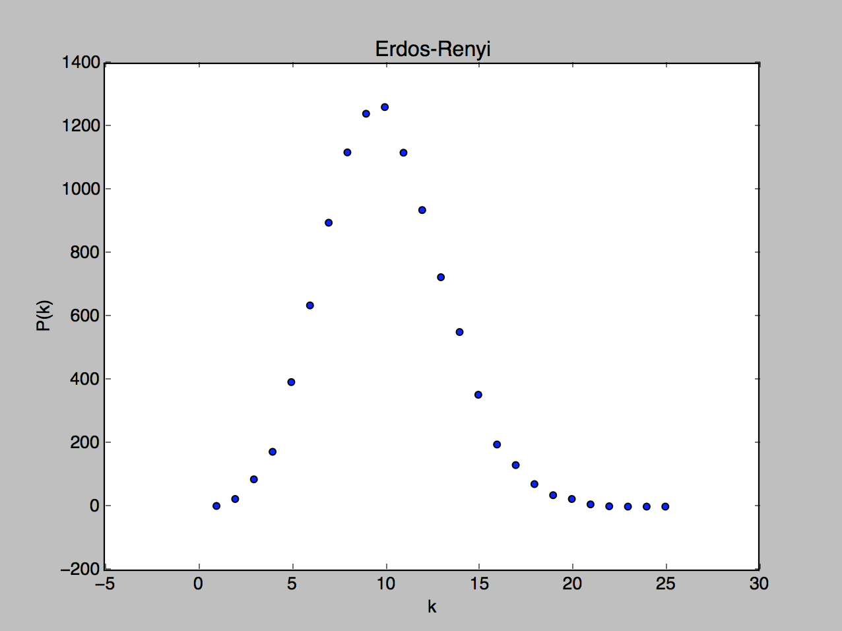

Number of Vertices: 10000

Number of Edges: 50000

Highest Vertex Degree: 25

The Erdos-Renyi graph is generated by selecting two random, unique vertices, connecting them with an edge, and then repeating this process until the desired number of edges is reached.

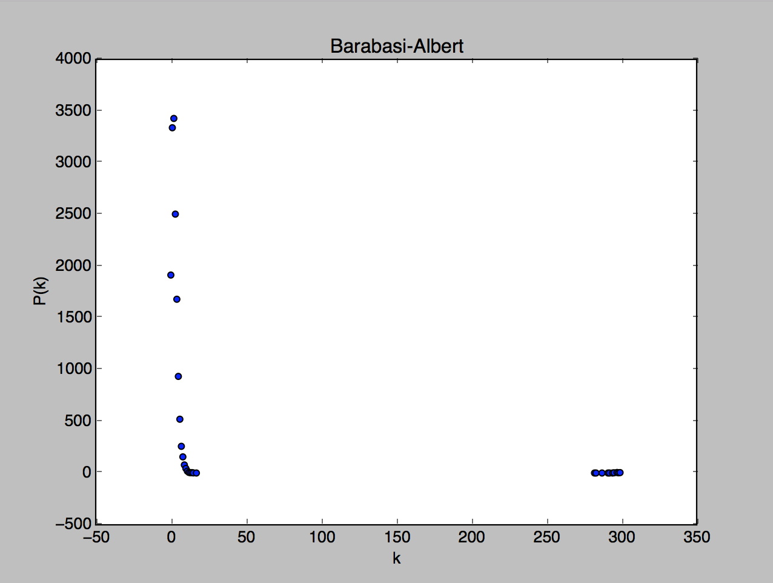

Number of Vertices: 15349

Number of Edges: 50000

Highest Vertex Degree: 354

$$P\left(k\right)= 3372*{\left(k-2\right)}^{-3}, k≥3$$